**20140901 - Beagle Bone Black Serial Port Setup**

Last week I did a demo of the BBB talking to an Arduino Uno for the Hero Jr Robot conversion. There were a couple of things to take away from that demo. 1st I setup the Arduino to read the keypad of the Hero Jr. The keypad is the original pad, and turns out it just a 4x4 matrix style keypad. The RESET button still doesn’t work, but will.

The take away from this was that keypad matrix seem to fairly universal 4x3 or 4x4 and in the case of the Hero Jr - they just rearranged the keys to make it look like it might be something different.

There is quite a bit of information in this document about the keypad matrix.

I also have the Photoresistor working on the Arduino.

The most important take away thou is how to setup one of the serial ports on the BBB - remember BBB has four UARTs.

Most of the information on how to enable them seems wrong is confusing, I finally came across this and it will enable the serial ports for python.

<https://github.com/alexanderhiam/PyBBIO/wiki/Installing-PyBBIO>

Depending on which distro is installed on your device will depend on how you enable and install the serial ports.

Installing PyBBIO will also enable some of the other features of the board.

Very good library, very easy to use once it’s installed, very easy to install using the above site. Loads of information can be found here:

<https://github.com/alexanderhiam/PyBBIO/wiki>

For those interested here is a picture of the I/O pins:

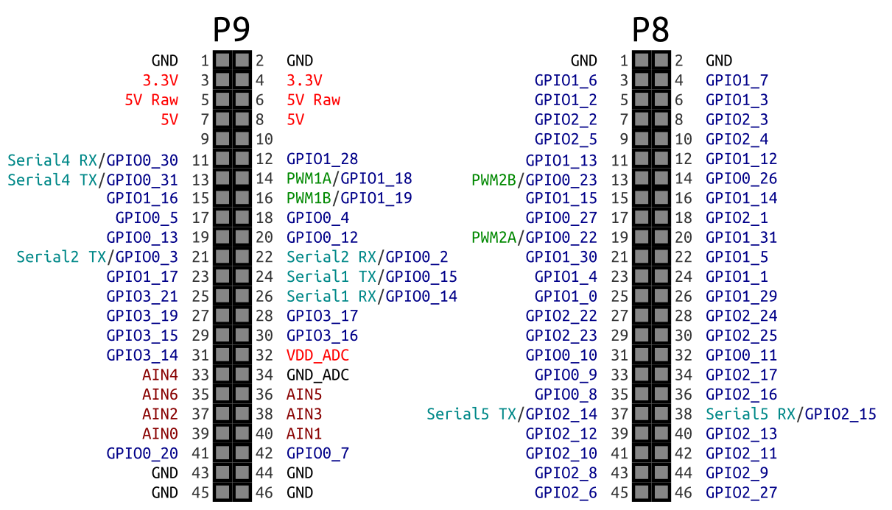

This image shows all the pins currently supported by PyBBIO, color coded by type, and each with the same name as its pin constant.

The 5V Raw pins are connected directly to the DC barrel jack, so they can be used when driving higher current devices like motors or relays.